**BCD-MBR Tools**

* BootIce v1.3.3
* EasyBCD v2.3

**Hard Disk Tools – Data Recovery**

* CheckDisk GUI v1.2.0
* Lazesoft Data Recovery v4.0.0.1
* Puran Data Recovery v1.2.0
* Puran File Recovery v1.2.0
* Recuva v1.53.0.1087
* Runtime GetDataBack for FAT v4.3.3
* Runtime GetDataBack for NTFS v4.3.3
* Runtime GetDataBack Simple v5.0.0
* Runtime NAS Data Recovery v4.0.0
* Runtime RAID Reconstructor v4.4.0
* Runtime RAID Recovery for Windows v4.0.0

**Hard Disk Tools – Defrag**

* Defraggler v2.22.33.995

**Hard Disk Tools – Diagnostic**

* GSmartControl v1.1.3
* HDDScan v4.0
* HDTune v2.55
* WD Data Lifeguard Diagnostics v1.31

**Hard Disk Tools – Disk Explorer**

* Runtime Captain Nemo v7.0.0
* Runtime DiskExplorer for FAT v4.3.2
* Runtime DiskExplorer for Linux v4.3.6
* Runtime DiskExplorer for NTFS v4.3.2

**Hard Disk Tools – Imaging**

* Acronis TrueImage 2018 build 11530
* AOMEI Backupper v4.1.0
* Lazesoft Disk Image & Clone v4.0.0.1
* Macrium Reflect PE v7.1.3196
* Runtime DriveImage XML v2.6.0

**Hard Disk Tools – Partition Tools**

* AOMEI Partition Assistant v7.0.1
* Macrorit Partition Extender v4.9.3

**Hard Disk Tools – Security**

* HDD Low Level Format Tool v4.40

**Windows Recovery**

* Lazesoft Windows Recovery v4.0.0.1

**Other Tools**

* FSViewer v6.5.0
* Free Office rev 703
* Sumatra PDF v3.1.2
* 7-Zip v18.05
* ExamDiff Pro v10.0.0.6
* HxD v2.0.0
* Notepad++ v7.5.6
* WinMerge v2.14

**Removable Drive Tools**

* CDBurnerXP v4.5.8.6795
* Rufus v3.0.1304

**Security – AntiVirus**

* ESET Online Scanner v2.0.22
* Malwarebytes Anti-Malware v2.2.1.1043

**Security – KeyFinders**

* ProduKey v1.92
* ShowKeyPlus v1.0.6610

**Security – Passwords**

* Lazesoft Password Recovery v4.0.0.1
* NT Password Edit v0.7

**System Tools**

* CPU-Z v1.85.0
* GPU-Z v2.9.0
* HWInfo v5.84-3450
* Speccy v1.32.740
* TechBench ISO Downloader v4.13
* WinNTSetup v3.9.0
* Attribute Changer v9.0
* CCleaner v5.43.6522
* Change Keyboard Layout v1.0.0
* Dependency Walker v2.2.6
* Registry Backup v3.5.3
* Regshot v2.0.1.70
* SysInternals Suite
* Windows PowerShell v1.0

**Network**

* Aero Admin v4.5
* Teamviewer v6.0.10511
* Acrylic Wi-Fi Home v3.3.0
* Chrome v67.0.3396.62
* Mozilla Firefox v60.0.1.6710
* PENetwork v0.59.0.4

|  |  |
| --- | --- |
| **Filename** | [HBCD_PE_x64.iso](https://www.hirensbootcd.org/files/HBCD_PE_x64.iso)*(Special thanks to our*[*Supporters*](https://www.hirensbootcd.org/supporters/)*for maintaining fast and reliable mirror servers)* |
| **Filesize** | 1292.04 MB (1354811392 bytes) |
| **ISO MD5** | 07170465C2F892088B7A725306737715 |
| **ISO SHA1** | 6CBC2FFFB4D0563852A43F7E16A67581BD6BD809 |
| **ISO SHA-256** | D67BCF0437A1BD27F31655C4A9C81C93269A5A239D43F38D0375618443D372BC |

**Screenshot**

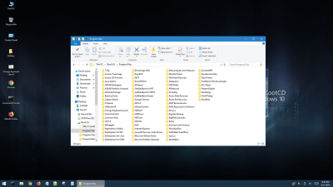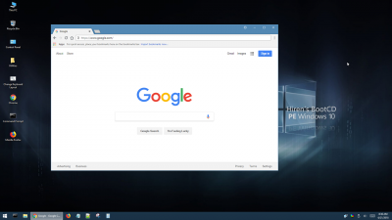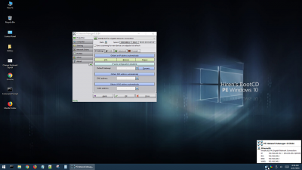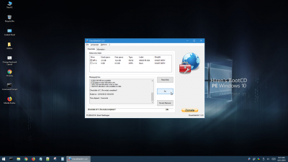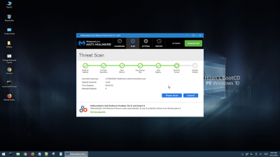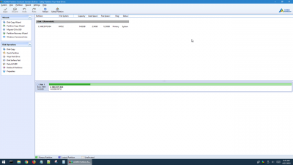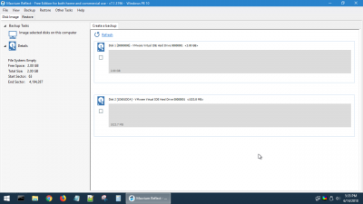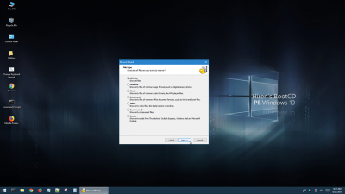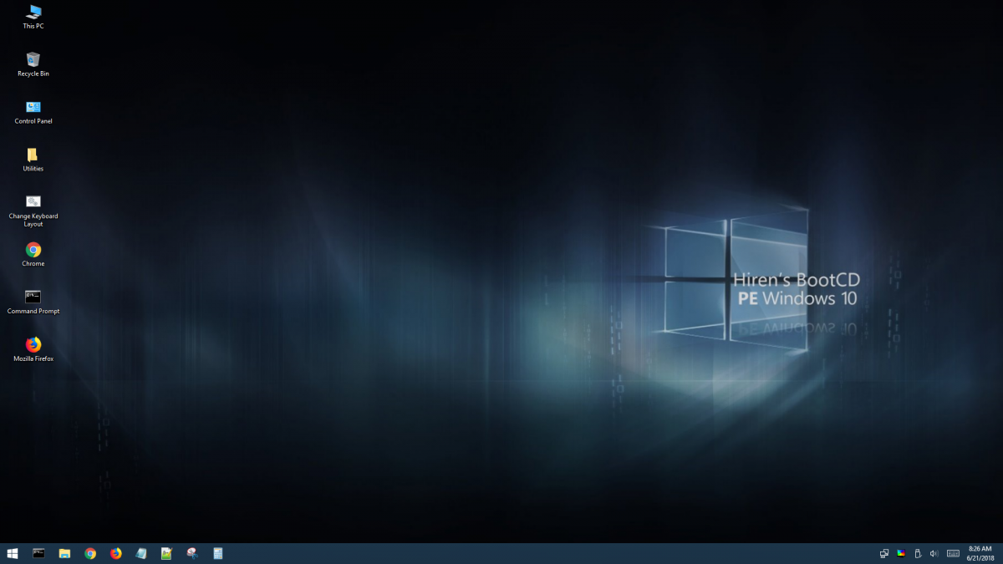



**Save Download From Google Drive:**

**https://goo.gl/ZVTQGQ**

**http://bit.ly/2R0xQn**

**http://dapalan.com/KqFZ**

**Scan to download Hacking Labs Live CD Kali Linux**